# Guide to GLD and I2D2 servers

Within the File Explorer (framed yellow below) find the “Network” option on the left-hand side menu (red box at the bottom). If you use secondary click (right-click) on it, a pop-up appears giving different options. Click on “Map network drive…” (green box).

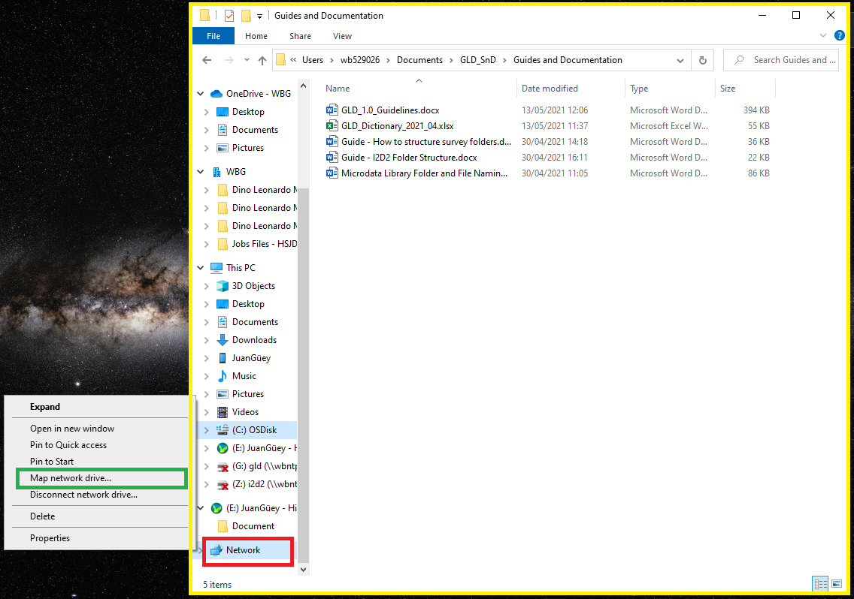

This will in turn cause another pop-up window to appear (shown below). You need to select what letter the mapped drive ought to have by choosing a letter (drop down box appears by clicking on the arrow in the red box). You also need to define the address the mapping should go to (green box). The two servers we will be working with are:

\\wbntpcifs\gld

\\wbntpcifs\i2d2

Once you have typed any one in, the currently greyed out “Finish” button (yellow box) should become available. Click on it and the process should be complete.

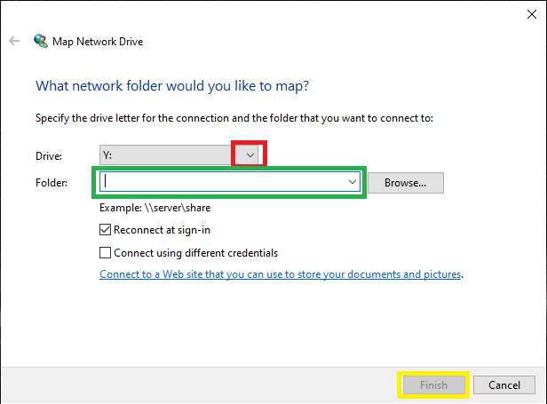

After finishing the new servers should be added and available under the “This PC” (or your name for your device) header.

